

Faculty of Computer Applications

MCA Sem-1 (AY-2026-27)

Lab Book

Sub Code: 05MC0108 (DBMS)

Enrollment No :
Full Name :

Sub.Faculty Name: Dr. Jaypalsinh A. Gohil

Index
Unit : 1 Exercise No | Unit : 1 Definition
1 | Write a PL/SQL block that find  - Area of Circle  - Area of Rectangle  - Circumference of Circle
2 | Write a PL/SQL block to accept product name, qty and price from user and then  calculate discount in Rs. based on the given (%).
3 | Write a PL/SQL block which displays gross salary of employees as per user input EID. (Consider EMP table with EID, EName, Deptno, Deptname Gender, Age, BasicSal) with appropriate data types.) Gross_Salary: BASICSAL + (DA + HRA + Medical) – PF. Rules: HRA = 15% of basic, DA = 50% of basic, Medical = Rs. 500,  PF = 10% of basic.
4 | Write a PL/SQL block which accepts measurement in feet and displays it in cm,  inch and meter.
5 | Write a PL/SQL block to calculate the square and cube of the given number.
6 | Write a PL/SQL block which accepts measurement in feet and displays it in cm,  inch and meter.
7 | Write a PL/SQL block which converts temperature from Celsius to Fahrenheit.
8 | Write a PL/SQL block to delete the record of employee for given EID.
9 | Write a PL/SQL block that calculates the simple interest based on given principal  amount, rate of interest and number of years.
10 | Write a PL/SQL block to calculate the square and cube of the given  number.
Unit : 2 Exercise No | Unit : 2 Definition
11
12
13

14
15
Unit : 3 Exercise No | Unit : 3 Definition
16
17
18
19
20
Unit : 5 Exercise No | Unit : 5 Definition
21
22
23

Write a PL/SQL block that find:
  - Area of Circle
  - Area of Rectangle
  - ​Circumference of Circle

/*
Write a PL/SQL block that find
- . Area Of Circle
- . Area Of Rectangle
3. Circumference of Circle
*/

SET SERVEROUTPUT ON SET FEEDBACK OFF
SET VERIFY OFF

DECLARE
PI CONSTANT NUMBER(3,2) := 3.14; R NUMBER(5);
CAREA NUMBER(7,2);

L NUMBER(5);
W NUMBER(5);
RAREA NUMBER(7,2);

CIR NUMBER(7,2);

BEGIN

R:=&R;

L:=&L;
W:=&W;

DBMS_OUTPUT.PUT_LINE('1. Area of Circle'); DBMS_OUTPUT.PUT_LINE('================='); CAREA:=PI*POWER(R,2);
DBMS_OUTPUT.PUT_LINE('The Area of Circle is: '||CAREA); DBMS_OUTPUT.PUT_LINE('=============================='); DBMS_OUTPUT.PUT_LINE(' ');

DBMS_OUTPUT.PUT_LINE('2. Area Of Rectangle'); DBMS_OUTPUT.PUT_LINE('===================='); RAREA:=(L*W);
DBMS_OUTPUT.PUT_LINE('The Area of Rectangel is: '||RAREA);

DBMS_OUTPUT.PUT_LINE('================================='); DBMS_OUTPUT.PUT_LINE(' ');

END;
/
DBMS_OUTPUT.PUT_LINE('3. Circumference of Circle'); DBMS_OUTPUT.PUT_LINE('=========================='); CIR:= (2*PI*R);
DBMS_OUTPUT.PUT_LINE('The Circumference of Circle is: '||CIR); DBMS_OUTPUT.PUT_LINE('=====================================');

SET SERVEROUTPUT OFF SET FEEDBACK ON
SET VERIFY ON

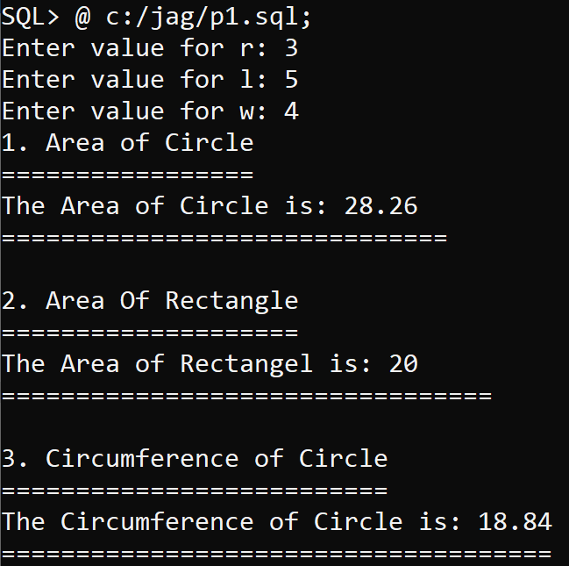
Output:

